Style Guidelines for Final Year Project ReportsDIABUDDY
Final Year Project Proposal
Session 2023-2027
A 4th Year Student

A project submitted in partial fulfillment of the requirements for the Degree
of
BSc. (Hons.)BS in Computer Science / Software Engineering



Department of Computer Science
COMSATS University Islamabad (CUI), Lahore Campus

Project Registration
Project ID (for office use)
Type of project |  |  | [✔] Traditional [ ] Industrial [ ] Continuing
Nature of project |  |  | [✔ ] Development [ ] Research & Development
Sustainable Development Goals(SDGs) |  |  | [✔ ] Good Health and Well-Being [ ] Quality Education  [ ] Industry, Innovation, and Infrastructure [ ] Gender Equality  [ ] Decent Work and Economic Growth [ ] Climate Action
Area of specialization |  |  | [✔ ] Artificial Intelligence (AI) [ ] Blockchain [ ] Cybersecurity  [✔ ] Data Science and Analytics [ ] Game Development  [✔ ] Internet of Things (IoT) [ ] Natural Language Processing (NLP)  [ ] Mobile App Development [✔ ] Web Development
Project Group Members
Sr.# | Reg. # | Student Name |  | Email ID | Phone # | Signature
(i) | FA23-BSE-172 | SHIFA ZAMAN |  | FA23-BSE-172@cuilahore.edu.pk | +92 342 8616161 | shifa
(ii) | FA23-BSE-069 | LAIBA SADIQ |  | FA23-BSE-069@cuilahore.edu.pk | +92 322 3871813 | laiba
(iii) | FA23-BSE-162 | RIDA ANJUM |  | FA23-BSE-162@cuilahore.edu.pk | +92 325 3657672 | rida
Declaration: FYP group members have cleared all prerequisite courses For FYP-I as per their degree requirements.
For BS (Computer Science), BS (Software Engineering), and BS (Artificial Intelligence)
(CSC241 Object Oriented Programming, CSC291 Software Engineering Concepts, CSC270 Database Systems, HUM102 Report Writing Skills)
Plagiarism Free Certificate
This is to certify that, I am _Shifa Zaman_ S/D/o _Zaman Butt__, group leader of FYP under registration no CUI / FA23-BSE-172 /LHR at the Computer Science Department, COMSATS Institute of Information Technology, Lahore. I declare that my FYP proposal is checked by my supervisor and the similarity index is ________% that is less than 20%, an acceptable limit by HEC. The report is attached herewith as Appendix A.
Date: _2ND March , 2026_ Name of Group Leader: _Shifa Zaman__ Signature: _____shifa_____
Name of Supervisor: __Usman Akram__ Co-Supervisor (if any):_________________
Designation: _____________________ Designation: _____________________
Signature: _____________________ Signature: _____________________
Contents
ABSTRACT 4
1. INTRODUCTION 4
1.1 Domain Background 4
1.2 Motivation and Significance of the Project 4
1.3 Objectives and Scope of the Project 5
1.4 Proposed Solution 5
1.5 Results or Outcomes 5
2. PROBLEM STATEMENT 5
3. PROJECT OBJECTIVES 6
4. Related work 6
5. Proposed Methodology and Architecture 7
5.1 Proposed Methodology 7
5.2 Proposed Architecture 8
6. SUCCESS CRITERION 10
7. Team Roles and Responsibilites 11
7.1 Gantt Chart 11
8. Tools and Technologies 12
9. References 13

TABLES OF FIGURES
Figure 1: system architecture 9
Figure 2: block diagram 9
Figure 3:Flow chart 9
Figure 4:Gantt chart 11
Figure 5:activity task 12

ABSTRACT
Diabetes is a persistent illness that demands unremitting attention and control of blood glucose level, insulin dosage, nutrition, and physical exercises. As the problem of diabetes is on rise among patients across the globe, self-management has become necessity. Most people have difficulties in keeping regular health record. The digital health platforms are also coming up as supportive in enhancing patient awareness and lifestyle management.Most individuals with diabetes struggle to monitor their daily health practices including insulin intake, food intake and physical exercise. Without having proper monitoring, it may result in poor glycemic control and health complications. Also, a lack of access to formal support systems decreases patient interaction and motivation. The centralized and organized system is required to make diabetes self-management easy.The suggested system will be an online health-centered platform specifically oriented on the population of individuals with diabetes. It enables users to record the insulin, blood glucose levels, meals and physical activities in orderly fashion. Other community support features including forums and messaging are also offered in the platform so as to facilitate peer interaction. Moreover, it creates daily, weekly, and monthly reports to enable the user to analyze their health progress.The system will enhance awareness of patients and promote regular health monitoring. Well-organized records and summarized reports will help users to track their condition more efficiently. Community support capabilities will make the users more motivated and share knowledge. In general, the platform will help to facilitate the improvement of diabetes management and healthier lifestyle choices.

INTRODUCTION

Domain Background
Diabetes is a chronic metabolic disorder and has millions of victims worldwide and it must be managed under self-management lest it complicates tremendously. The secrets of effective management of diabetes include monitoring of the blood glucose level, insulin, diet, physical exercise, and compliance with medications. Poor management can lead to severe diseases such as heart diseases, kidney failure and paralysis of the nerves. Regular surveillance and management of lifestyle are hence the crucial elements in management of diabetes. However, the majority of the patients cannot maintain a systematic record of their everyday health condition and, therefore, cannot identify patterns as well as make reasonable health decisions.
With the growing extent of the digital health solutions, the online platforms and mobile applications started playing a big role in personal health monitoring. One can use different apps, which allow the user to monitor their glucose or medication reminders. Despite such developments, the majority of the existing systems focus on single features instead of providing an integrated and comprehensive platform of diabetes management. In addition, lack of involvement in the community and well-organized progress reports makes the patients less engaged and less motivated in the long run. It still needs to be centralized, convenient, and organized whereby health logging, and community support monitoring and analysis are done in a single platform. Moreover, health tracking features should be combined with analytical insights in order to allow patients to learn more about their health habits and make a better choice regarding their lifestyle and treatment. A properly designed system can also help healthcare providers to have a better time in reviewing the patient data. Such a platform may help to promote self management by reminding , and creating a community surrounding users.

Motivation and Significance of the Project
This project is motivated by the fact that diabetes is becoming more prevalent the world over and that patients are unable to adhere to disciplined self-care practices. Digital health management studies indicate that a regular measurement and feedback system would greatly enhance patient outcomes and treatment plan adherence. Nevertheless, there is a high possibility of inconsistency of data and demotivation by having fragmented tools and manual record-keeping. The importance of this project is that it will offer a structured and well-organized digital solution that would assist patients to analyze, monitor, and interpret their health information in a more efficient manner. The system will aim to increase patient awareness, facilitate healthier practices, and lead to improved diabetes management in the long term because it provides a single platform where patients can monitor their well-being and interact with their community..

Objectives and Scope of the Project
The main goal of the project is to plan and create an online health-oriented platform with special reference to diabetes self-management. The system should allow users to record the insulin intake and the blood sugar levels, meals, and physical activities and drug schedule in systematic format. It is also expected to produce daily, weekly and monthly progress reports in order to analyse health better. The other aim is to incorporate the functionalities of communities like forums and messages to facilitate peer support and learning together.The project scope will encompass user authentication and logging, generation of reports, notification of reminders, and community interaction. It also has data storage and report visualization features in form of structures. The system is not, however, intended to substitute the professional medical diagnosis or offer direct clinical treatment or to integrate with hospital record systems. It is pure and there is no commercial element involved as the site is a pure self-management and supportive monitoring tool among the people with diabetes.

Proposed Solution
The method suggested is an online system which consolidated health tracking related to diabetes and community interaction with each other in to a single system. Users will be in a position to add daily entries like insulin dosage, blood glucose levels, food records and physical exercise. The system will also measure the stored data and produce summarized reports that will enable the users know the trends and patterns of their health behavior. A meal tracking aspect will help users to trace the nutritional elements of the entries made, and the activity tracking will aid in the general health monitoring aspect.The platform will also have a discussion feature, a personal messaging system to ensure interaction and exchange of experiences among the users. A reminder module will be used to remind users of medication schedules and recording activities. The proposed system is able to solve the shortcomings of the disparate health tools and offers an all-encompassing management system by incorporating monitoring, analysis, and social support.

Results or Outcomes
The results that are anticipated in this project are the establishment of a working and convenient diabetes management system that enhances self-monitoring adherence. The system is expected to increase the awareness of patients with the system through structured reports and visual summaries of health data. The acceptance of the project is going to be determined by the capability of the system in keeping the accurate logs, creating the purposeful reports, and supporting the user engagement with the help of the community features. Working modules, reports generated, interface demonstrations and testing results will all be evidence of achievement. On the whole, the project will be dedicated to make contributions on the improvement of diabetes self-management and health discipline among the users.

PROBLEM STATEMENT
Management diabetes involves constant checking of the level of blood sugar, insulin dosage, the foods and activities as well as taking of medications, but some people find it very hard to keep regular and systematic health records. The available digital solutions tend to be one-sided and include few features like glucose tracking or notifications without an integrated platform that correlates tracking, data analysis, and social support. This can be difficult to users in terms of them gaining insight on health trends, staying motivated and making informed lifestyle choices due to this fragmentation. Manual records further contribute to the risks of no data loss, inconsistency, and bad self-management practices. Moreover, a decreased peer interaction and formal progress reporting leads to poor patient engagement with time. By breaking these constraints, an integrated system will be able to enhance and improve the management of diabetes in the long run.

PROJECT OBJECTIVES
- To create a web-based application that will allow organized recording of insulin, blood glucose, meals, and physical activity and medication timetables.
- To construct a stratified system architecture that will guarantee secure data storage, systematic processing, and effective report generation.
- To create an automated way of reporting to create daily, weekly, and monthly health summary in order to analyze the progress.
- To develop and incorporate the community forum and messaging feature to improve peer support and knowledge sharing.
- To develop a convenient dashboard interface with easy access to personal health data monitoring and visualization.
- To measure the system in terms of functionality, report accuracy, usability, and system engagement measures.

Related work
The research below examines diverse digital health devices and community-based platforms that are already used to manage diabetes. The choice of these resources was based on the fact that they integrate medical tracking with peer support, which allows taking a full look at the features that users can use today. The technical opportunities as well as social characteristics of each platform are described in the table below to illustrate the particular advantages of each platform in day-to-day care..

Related websites / apps | Watch Sync | Photo Logging | Insulin Dose Calculator | Community | Data History | Trend Graphs
mySugr | Yes | Yes (Pro) | Yes | No | Yes | Yes
Glucose Buddy | Read-Only | No | No | No | Yes | Yes
FreeStyle Libre | Yes | AI Assist | No | No | Yes (AGP) | Yes (AGP)
Dexcom G6 | Yes | No | No | No | Yes (AGP) | Yes (Clarity)
TuDiabetes | No | No | No | Yes | No | No
Diabetes Daily | No | No | No | Yes (Active) | No | No
Diabetes.co.uk | No | No | No | Yes (Large) | Limited | No
Details of platforms are given below:
- mySugr [1]: An all-inclusive mobile application with watchOS. It has visual food logging in the Pro version as well as is the only platform that has a Clinical Decision Support bolus calculator. It upholds multi-variable event logging and biometric trend analysis.
- Glucose Buddy: An app that provides smartwatch app support through HealthKit. Although it does not have visual food logging and clinical calculators, Glucose Buddy [2] offers strong multi-variable digital health records and trend analysis.
- FreeStyle Libre [3]: An open medical hardware-software environment that uses watchOS and Android Wear. It has the AI predictive Libre Assist food logging and produces Ambulatory glucose profile (AGP) reports to analyze the biomedicine.
- Dexcom G6: Continuous glucose monitoring (CGM) system that is compatible with watchOS and Garmin connect IQ. Dexcom [4] specializes in professional level data, providing AGP reports and trend analysis through the platform called Clarity..
- TuDiabetes [5] : A special User Forum and Discussion board. It is more of a social support system and lacks such technical modules as wearable integration, food logging, and clinical calculators.
- Diabetes Daily: They have an active community platform which has sections such as Type 1 and Type 2 diabetes, a Social area where people can talk about non-medical related questions and peer-advice on technology and recipes.
- Diabetes.co.uk Forum [6] : Huge international community with its Low Carb Program sub-forums and the welcoming atmosphere to newly diagnosed persons.
Although the above-mentioned platforms are very well-performed regarding their individual features, users receive the impression that they must navigate among numerous apps to have the full-fledged support they need. We intend to create a coordinated site where all of these necessary functions of clinical tracking to community discussion will be put together into one, smooth package. Through this unification, we hope to remove the technical challenges that most diabetes patients are having at the moment

Proposed Methodology and Architecture

Proposed Methodology
The Incremental Software Development Model will be used in the development of the proposed Diabetes Online Platform. Incremental model is very applicable to small to medium scale projects since the system may be developed in smaller segments (increments) and therefore easier to control, test and refine.
Under this method, the entire system gets broken down into several functional modules. The modules are built, tested and implemented individually. Once a successful increment has taken place, another increment gets added into the system.
Our system Incremental process will be carried out in the following stages:
- Gather the Requirements
During this stage, the functional and non-functional requirements of the system are all defined. Health log management (insulin, blood glucose, exercise), uploading meal images and AI analysis, Fitbit synchronization, communication in the forums, generation of reports, and medication reminders are functional requirements. Security, performance, usability and reliability are some of the non-functional requirements.
- System Design
General system architecture is planned such as database design, user interface design and system diagrams (Flowchart, Block Diagram, Activity Diagram). It is also planned to integrate external API during this stage.
- Incremental Development
The system will be created in the following increments:
Increment 1: Authentication.
Increment 2: Log Management Module (Insulin, Glucose, Exercise, Meal Upload)
Increment 3: Wearabale Integration Module.
Increment 4: Forum Module
At every increment, a working system portion will be created.
- Testing
During this, after every increment, testing is carried out to ascertain the functionality of the module. This involves unit testing and integration testing prior to its inclusion to the main system.
- Deployment
Once all the increments are made, the entire system will be implemented as a Web Application on a secure cloud server with HTTPS functionality.
- Maintenance & Improvement
There can be added on further improvements and enhancements in form of incremental steps but without disrupting the existing system.

Proposed Architecture
The proposed diabetes self management platform follows a Layered Architecture approach to the system architecture in order to have clear separation of responsibilities and more effective organization of the system.
The structure of the architecture is built with the three most important layers:
The Presentation Layer deals with the user interface, dashboards, forms, health log entry screens, and report views which provide the user with effective interaction with the system.
The Business Logic Layer deals with the fundamental functionality of the platform like health log processing, creation of progress report, processing of reminder notifications and facilitation of forum interactions.
The Data Access Layer plays the role of storing and accessing system data such as user data, health records, reports and forum records.
This hierarchy enhances system maintainability, modularity and scalability, which makes the platform easier to support, upgrade as well as add features in future.
System Architecture Flow
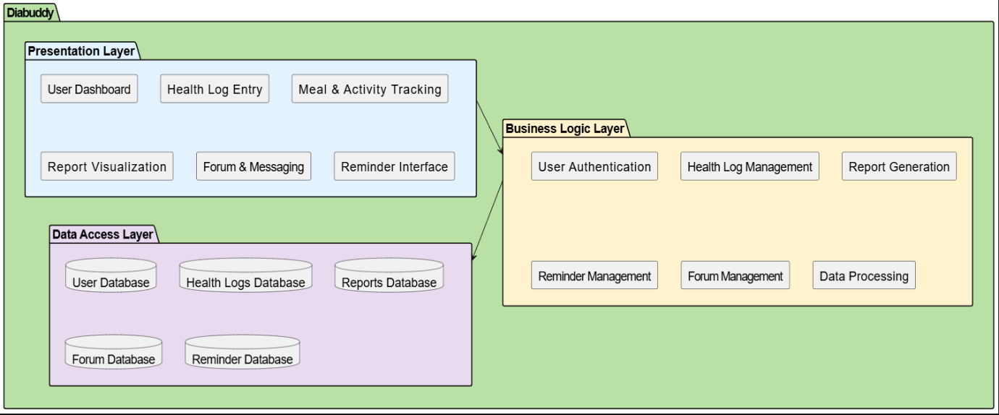
Figure 1: system architecture

Block Diagram
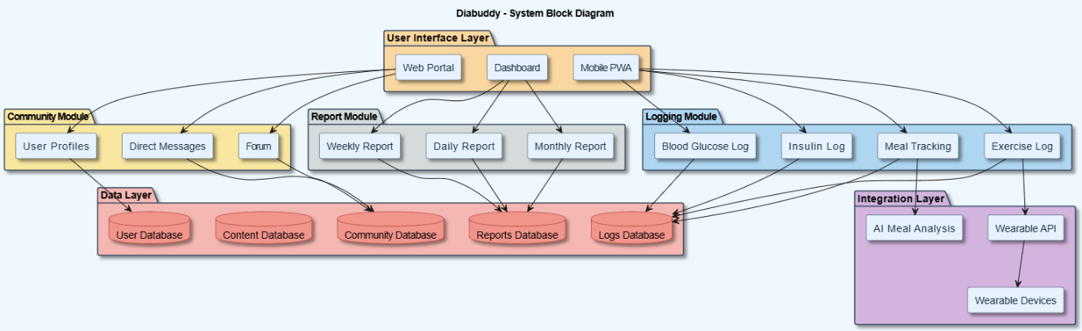
Figure 2: block diagram

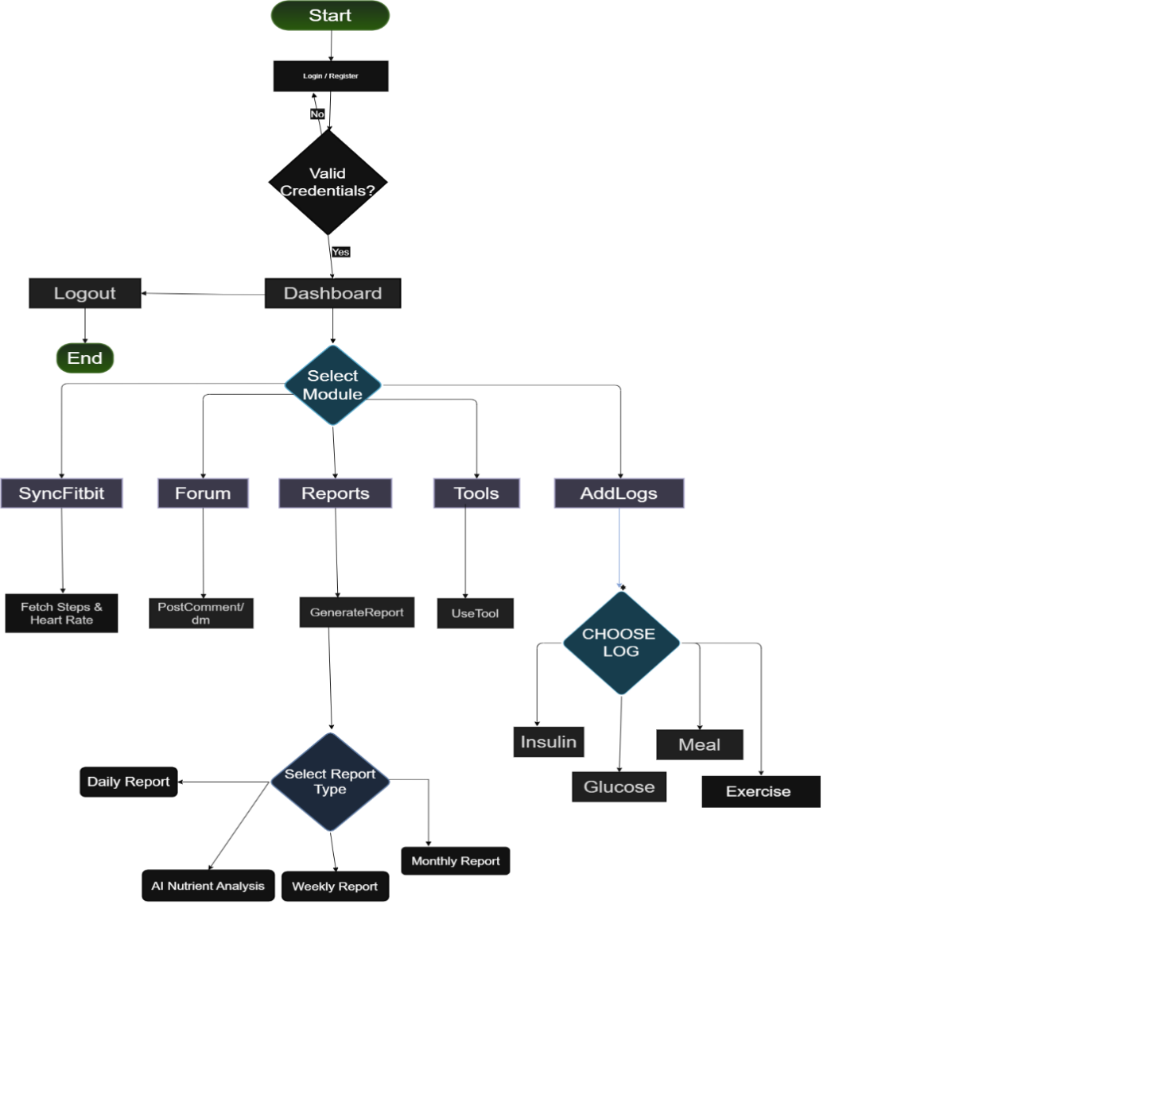
Flow Chart
Figure 3:Flow chart

SUCCESS CRITERION
The project will be said to have been successful when the designed diabetes management platform puts to full implementation the objectives stipulated in Section 3 and functions as suggested in the project plan. The success will be determined by the system to be able to record and store the user data such as insulin logs, blood glucose level, meal records, physical activity, and medication schedules without loss and inconsistency of the data. The platform will need to be able to produce daily, weekly, and monthly health reports, which succinctly summarize the progress of the user and show significant trends.
Moreover, the message and discussion features should enable the users to post, comment, and interact smoothly devoid of functional faults. The user interface must be friendly, alive and reachable and must give the user a good experience. System testing should ensure that all modules are working correctly and are capable of accepting functional requirements as required. Assessment of the project will also be done in terms of demonstration outcomes, system documentation and ensuring that all the objectives mentioned have been met. The project supervisor will be the person who will give official confirmation of success. Unless the system merely satisfies these set benchmarks, e.g. increased usability or extended reporting capabilities, it can be concluded that this project is highly successful.

Team Roles and Responsibilites
The following table outlines the respective roles of each of the team members regarding the development of the proposed system. It also makes sure that the work in the project is systematically distributed over the project timeline, with each member of the project contributing his or her work based on their skills and expertise. The duties encompass all major stages of the project such as the requirement analysis, system design, development of the modules, implementation, testing and eventual deployment of the project so that successful completion of the project is achieved within the planned time line.
Team Member | Activity | Tentative Date
Laiba,Rida,Shifa | Requirnment gathering | February 2026
Laiba,Rida,Shifa | System Design & Architecture | March 2026
Laiba,Rida,Shifa | UI/UX Design | March – April 2026
Laiba,Rida | Authentication Module | April – May 2026
Laiba,Shifa | Log Management Module | May – June 2026
Rida,Shifa,Laiba | Database Implementation | June – July 2026
Rida,Shifa | Wearable Integration Module | July – August 2026
Rida,Laiba | Community Forum Module | August – September 2026
Shifa,Rida | Reminder / Notification Module | September 2026
Laiba,Shifa | Report Generation Module | September – October 2026
Laiba,Rida,Shifa | System Testing & Bug Fixing | October – November 2026
Laiba,Rida,Shifa | Deployment | November – December 2026
Laiba,Rida,Shifa | Documentation & Final Report | December 2026 – January 2027
Table 1: Individual Tasks

Gantt Chart
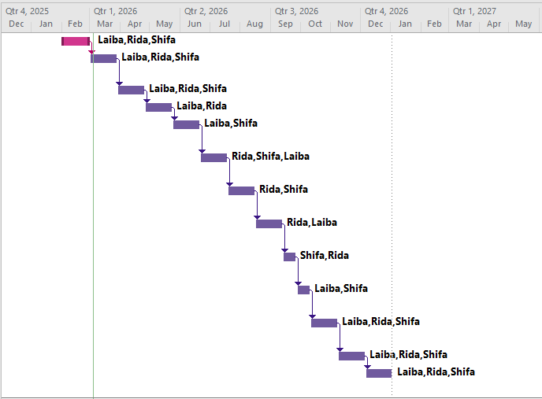
Figure 4:Gantt chart
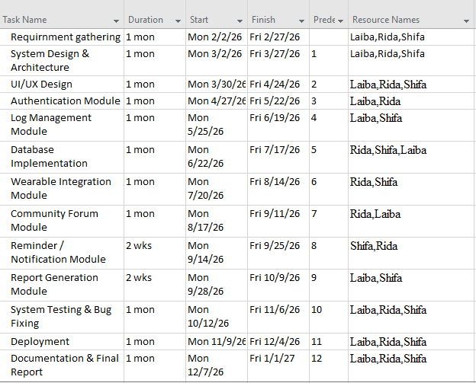
Figure 5:activity task

Tools and Technologies
Frontend
- Built using React
- Provides interactive and responsive user interface
- Handles user interactions and displays data
Backend
- Developed using Node.js with Express
- Provides RESTful APIs
- Handles business logic and communication between frontend and database
Database
- Used for storing and managing application data
- Supports efficient data retrieval and updates
Authentication & Security
- Secure user authentication and authorization
Password encryption
- Role-based access control
- Secure communication using HTTPS
External APIs
- Integration with third-party services
- Used to extend application functionality
Data Visualization
- Graphs and charts used to present data clearly
- Helps users understand insights easily

References

[1] | “mySugr,” 2024. [Online]. Available: https://www.mysugr.com/en/diabetes-app..
[2] | “Glucose Buddy,” Glucose Buddy Diabetes Tracker, [Online]. Available: https://www.glucosebuddy.com/.
[3] | “Freestyle Libre,” FreeStyle LibreLink, [Online]. Available: https://www.freestyle.abbott/.
[4] | “Dexcom,” Dexcom G6, [Online]. Available: https://www.dexcom.com/g6-cgm-system.
[5] | “TuDiabetes,” TuDiabetes Community, [Online]. Available: https://tudiabetes.org/.
[6] | “Diabetes Forum - The Global Diabetes Community,” Diabetes Digital Media Ltd UK , [Online]. Available: https://www.diabetes.co.uk/forum/.
[7] | O. El-Gayar, P. Timsina, N. Nawar and W. Eid, “Mobile Applications for Diabetes Self-Management: Status and Potential,” Journal of Diabetes Science and Technology, p. 247–262, 2013.
[8] | P. Povalej Bržan, E. Rotman, M. Pajnkihar and P. Klanjšek, “Mobile Applications for Control and Self-Management of Diabetes: A Systematic Review,” Journal of Medical Systems, p. 210, 2016.
[9] | S. Goyal, C. Nunn, M. Rotondi, A. Couperthwaite, S. Reiser, A. Simone, D. Katzman and J. Cafazzo, “A Mobile App for the Self-Management of Type 1 Diabetes Among Adolescents: A Randomized Controlled Trial,” JMIR mHealth and uHealth, no. e82, 2017.
[10] | A. Queirós, A. Silva, J. Alvarelhão, N. Rocha and A. Teixeira, “Requirements of an Application to Monitor Diet, Physical Activity and Glucose Values in Patients with Type 2 Diabetes,” Procedia Computer Science, no. 103-110, 2018.

Appendix A

Include here the 1st page of Turnitin Report (MANDATORY)
Every supervisor has his/her own Turnitin account. If not, then supervisors are requested to get the account from Library as soon as possible.

Appendix B

Include here the 1st page of AI Report generated through Turnitin (MANDATORY)
Every supervisor has his/her own Turnitin account. If not, then supervisors are requested to get the account from Library as soon as possible.

